**Name _____________________________ Period ____________________________**

**Resources Quiz**

**Directions: Circle the letter of the best answer choice.**

1. Which is a non-renewable resource?

a.) water b.) air c.) oil d.) soil

1. What is the MAIN reason non-renewable resources may run out in the future?
   * 1. the population of the world is slowly growing smaller
     2. the population of the world is slowly growing larger
     3. the population of the world is rapidly growing larger
     4. the amount of renewable resources is getting larger
2. Which is a renewable resource?

a.) copper b.) coal c.) natural gas

d.) wood

1. Which of the following resources produces the LEAST pollution?

a.) solar energy b.) natural gas c.) nuclear energy

d.) petroleum

1. Which of the following is a problem with using wind energy?

a.) air pollution b.) it is non-renewable c.) some places have little wind

1. Energy that is created by falling water is known as

a.) solar energy b.) geothermal energy c.) hydroelectric energy

d.) biomass

1. Energy that is created deep within the Earth is known as

a.) solar energy b.) geothermal energy c.) hydroelectric energy

d.) biomass

1. Organic matter that contains stored energy (and can be burned) is known as

a.) solar energy b.) geothermal energy c.) hydroelectric energy

d.) biomass

1. Energy that is created as sunlight is captured is known as

a.) solar energy b.) geothermal energy c.) hydroelectric energy

d.) biomass

1. Turning water off while brushing your teeth is an example of ____________ resources.

a.) recycling b.) conserving c.) reducing d.) replenishing

1. Discuss the difference between renewable and nonrenewable resources.
2. Choose one alternative source of energy. Name it and give one advantage and one disadvantage.

**Directions: Label the following Natural Resources as either renewable or nonrenewable.**

**MCj04378310000[1] MCj04418220000[1]**

**13. ___________________ 14. _______________ 15. ________________**

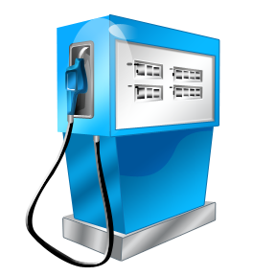 → 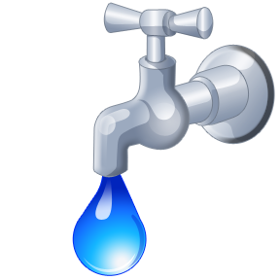 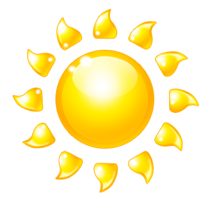

16. ________________ 17. _______________ 18. ________________

Directions: For the following items, tell a.) what natural resource the item is made from or uses

b.) whether the natural resource is renewable or non.

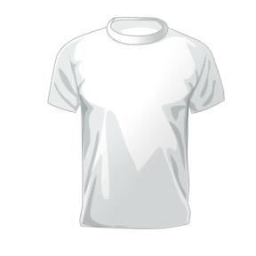 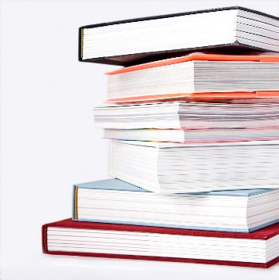 MCj02961890000[1]

T-Shirt Books/Paper Plastic Bottle

A.) A.) A.)

B.) B.) B.)